# Objective:

The Medical Data History Analysis project aims to improve healthcare delivery and operational efficiency by analyzing patient data using SQL, improving personalized care, optimizing resource allocation, supporting informed decision-making, and contributing to public health research. Business growth by answering simple questions.

# Medical Data History Analysis:

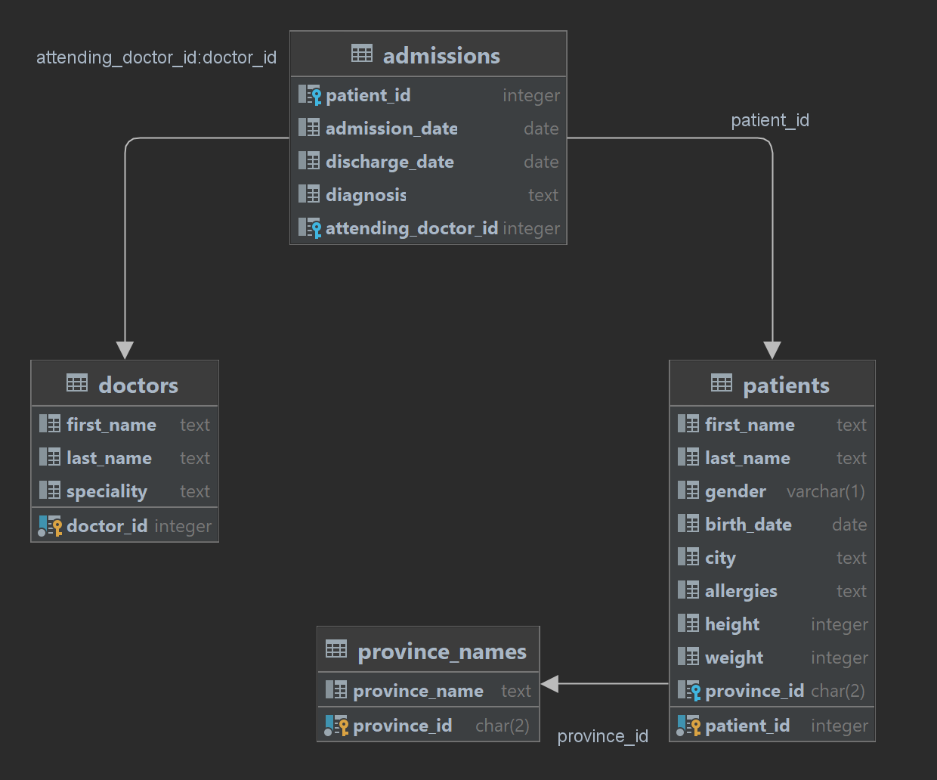



B Y **BHAGYASHRI PATIL**

**Q1 Show first name, last name, and gender of patients who's gender is 'M'.**

INPUT

select first_name,last_name,gender from patients

where gender= 'M';

OUTPUT

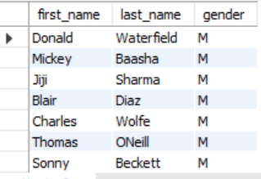

# Q2 Show first name and last name of patients who does not have allergies.

INPUT

select first_name,last_name,allergies from patients

where allergies is null;

OUTPUT

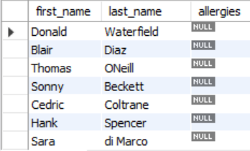

**Q3 Show first name of patients that start with the letter 'C'.**

INPUT

select first_name from patients

where first_name like "C%";

OUTPUT

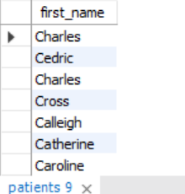

**Q4 Show first name and last name of patients that weight within the range of 100 to 120 (inclusive)**

INPUT

select first_name,last_name,weight

from patients

where weight between '100' and '120';

OUTPUT

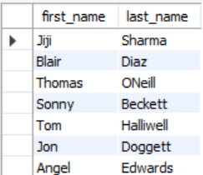

# Q5 Update the patients table for the allergies column. If the patient's allergies is null then replace it with 'NKA'.

INPUT

update patients

set allergies = 'NKA'

where allergies is NULL;

OUTPUT

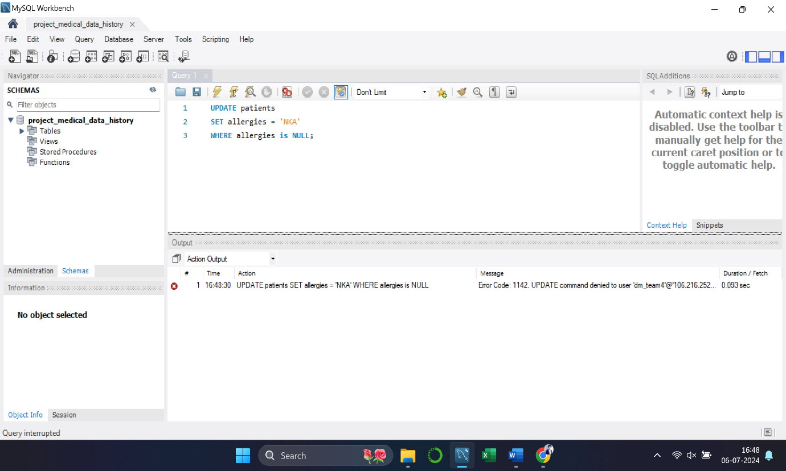

Q6 **Show first name and last name concatenated into one column to show their full name.**

INPUT

select concat(first_name," ",last_name) as full_name

from patients;

OUTPUT

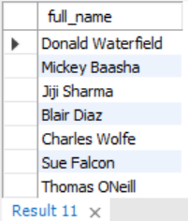



# Q7 Show first name, last name, and the full province name of each patient.



INPUT

select first_name,last_name,province_name

from patients

join province_names

on patients.province_id = province_names.province_id;

OUTPUT

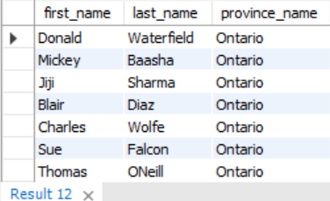

# Q8 Show how many patients have a birth_date with 2010 as the birth year.

INPUT

select count(*) as total_patients

from patients

where year(birth_date) = '2010';

OUTPUT

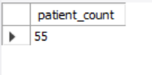

**Q9 Show the first_name, last_name, and height of the patient with the greatest height.**

INPUT

select first_name,last_name,height

from patients

where height = (select max(height) from patients);

OUTPUT

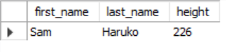

**Q10 Show all columns for patients who have one of the following patient_ids: 1,45,534,879,1000**

INPUT

select * from patients

where patient_id in (1,45,534,879,1000);

OUTPUT

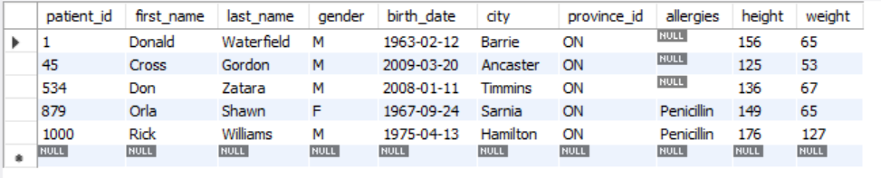

**Q11 Show the total number of admissions**.

INPUT

select count(*) as total_admissions

from admissions;

OUTPUT



**Q12 Show all the columns from admissions where the patient was admitted and discharged on the same day.**

INPUT

select * from admissions

where admission_date = discharge_date;

OUTPUT

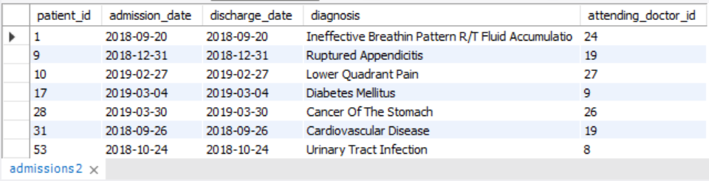

**Q13 Show the total number of admissions for patient_id 579.**

INPUT

select patient_id,count(patient_id) as total_admissions

from admissions

where patient_id = 579;

OUTPUT

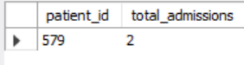

Q14 **Based on the cities that our patients live in, show unique cities that are in province_id 'NS'?**

INPUT

select distinct city from patients

where province_id = 'NS';

OUTPUT

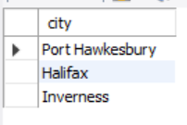

**Q15 Write a query to find the first_name, last name and birth date of patients who have height more than 160 and weight more than 70**

INPUT

select first_name,last_name,birth_date,height,weight

FROM patients

WHERE height > 160 AND weight > 70;

OUTPUT

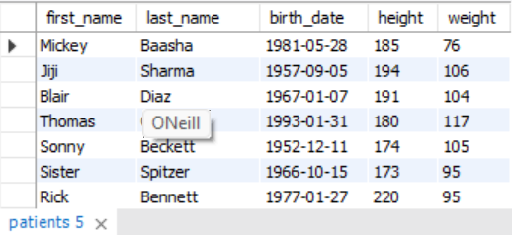

**Q16 Show unique birth years from patients and order them by ascending**.

INPUT

select distinct year(birth_date) AS birth_year

FROM patients

order by birth_year;

OUTPUT

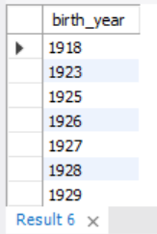

Q17 Show unique first names from the patients table which only occurs once in the list.

INPUT

select first_name from patients

group by first_name

having COUNT(first_name) = 1;

OUTPUT

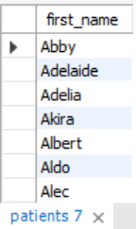

**Q18 Show patient_id and first_name from patients where their first_name start and ends with 's' and is at least 6 characters long.**

INPUT

select patient_id, first_name

from patients

where first_name like 's____%s';

OUTPUT

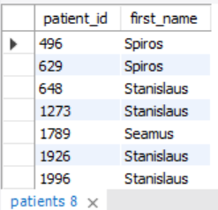

**Q19 Show patient_id, first_name, last_name from patients whos diagnosis is 'Dementia'. Primary diagnosis is stored in the admissions table.**

INPUT

select p.patient_id, p.first_name, p.last_name

from patients p

join admissions a on p.patient_id = a.patient_id

where diagnosis = 'Dementia';

OUTPUT

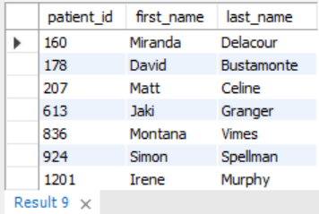

**Q20 Display every patient's first_name. Order the list by the length of each name and then by alphbetically.**

INPUT

select first_name

from patients

order by length(first_name), first_name;

OUTPUT

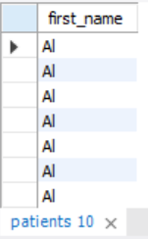

**Q21 Show the total amount of male patients and the total amount of female patients in the patients table. Display the two results in the same row.**

INPUT

select sum(gender = 'M') as male_count, sum(gender = 'F') as female_count

from patients;

OUTPUT

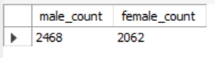

**Q22 Show the total amount of male patients and the total amount of female patients in the patients table. Display the two results in the same row.**

INPUT

select sum(gender = 'M') as male_count, sum(gender = 'F') as female_count

from patients;

OUTPUT



**Q23 Show patient_id, diagnosis from admissions. Find patients admitted multiple times for the same diagnosis.**

INPUT

select patient_id, diagnosis

from admissions

group by patient_id, diagnosis

having COUNT(diagnosis) > 1;

OUTPUT

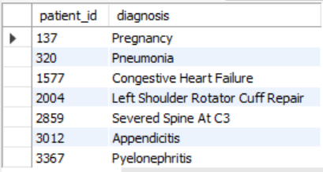

Q24 Show the city and the total number of patients in the city. Order from most to least patients and then by city name ascending.

INPUT

select city, COUNT(*) as number_of_patients

from patients

group by city

order by number_of_patients desc, city asc;

OUTPUT

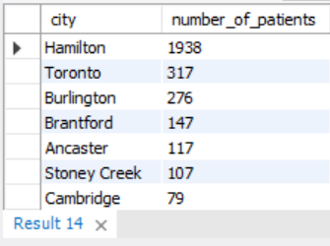

# Q25 Show first name, last name and role of every person that is either patient or doctor. The roles are either "Patient" or "Doctor".

INPUT

select first_name, last_name, 'Patient' as role

from patients

union all

select first_name, last_name, 'Doctor' as role

from doctors;

OUTPUT

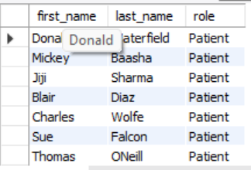

# Q26 Show all allergies ordered by popularity. Remove NULL values from query.

INPUT

select allergies, count(*) as total_diagnosis

from patients

where allergies is not null

group by allergies

order by total_diagnosis DESC;

OUTPUT

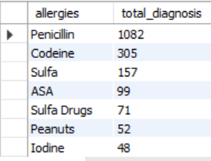

# Q27 Show all patient's first_name, last_name, and birth_date who were born in the 1970s decade. Sort the list starting from the earliest birth_date.

INPUT

select first_name,last_name,birth_date

from patients

where year(birth_date) between 1970 and 1979

order by birth_date ;

OUTPUT

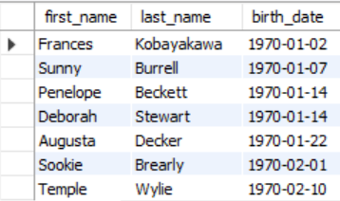

# Q28 We want to display each patient's full name in a single column. Their last_name in all upper letters must appear first, then first_name in all lower case letters. Separate the last_name and first_name with a comma. Order the list by the first_name in decending order.

INPUT

select concat(upper(last_name), ',', lower(first_name)) as new_name_format

from patients

order by first_name desc;

OUTPUT



# Q29 Show the province_id(s), sum of height; where the total sum of its patient's height is greater than or equal to 7,000.

INPUT

select pr.province_id, sum(pa.height) as sum_height

from province_names pr

join patients pa on pr.province_id = pa.province_id

group by pr.province_id

having sum(pa.height) >= 7000;

OUTPUT

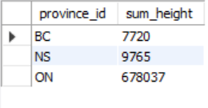

# Q30 Show the difference between the largest weight and smallest weight for patients with the last name 'Maroni'.

INPUT

select (max(weight) - min(weight)) as weight_diff

from patients

where last_name = 'Maroni';

OUTPUT

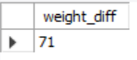

# Q31 Show all of the days of the month (1-31) and how many admission_dates occurred on that day. Sort by the day with most admissions to least admissions.

INPUT

select day(admission_date) as day_no,

count(patient_id) as no_of_admissions

from admissions

group by day_no

order by no_of_admissions desc;

OUTPUT

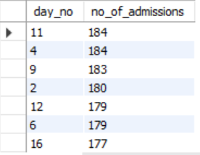

# Q32 Show all of the patients grouped into weight groups. Show the total amount of patients in each weight group. Order the list by the weight group decending. e.g. if they weight 100 to 109 they are placed in the 100 weight group, 110-119 = 110 weight group, etc.

INPUT

select floor(weight / 10) * 10 as weight_group,

count(*) as total_patients

from patients

group by weight_group

order by weight_group desc;

OUTPUT

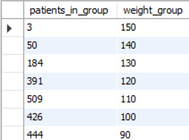

# Q33 Show patient_id, weight, height, isObese from the patients table. Display isObese as a boolean 0 or 1. Obese is defined as weight(kg)/(height(m). Weight is in units kg. Height is in units cm.

INPUT

select patient_id,weight,height,

case

when weight / power(height / 100.00, 2) >= 30

then 1

else 0

end as isobese

from patients;

OUTPUT

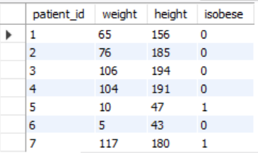

# Q34 Show patient_id, first_name, last_name, and attending doctor's specialty. Show only the patients who has a diagnosis as 'Epilepsy' and the doctor's first name is 'Lisa'. Check patients, admissions, and doctors tables for required information.

INPUT

select p.patient_id, p.first_name, p.last_name,d.specialty

from patients p

inner join admissions a on p.patient_id = a.patient_id

inner join doctors d on a.attending_doctor_id = d.doctor_id

where a.diagnosis = 'Epilepsy'and d.first_name = 'Lisa';

OUTPUT

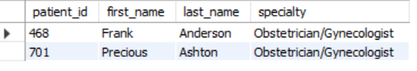

**Q35 All patients who have gone through admissions, can see their medical documents on our site. Those patients are given a temporary password after their first admission. Show the patient_id and temp_password.**

**The password must be the following, in order:**

**- patient_id**

**- the numerical length of patient's last_name**

**- year of patient's birth_date**

INPUT

select distinct p.patient_id, concat(a.patient_id, length(p.last_name), year(p.birth_date)) as temp_password

from patients p

inner join admissions a on p.patient_id = a.patient_id;

OUTPUT

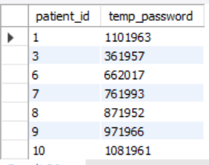

**Linkedin :** <https://www.linkedin.com/in/bhagyashri-patil0229/>

Github : <https://github.com/bhagyashridevkar>

Email : [bhagyashri.patil0229@gmail.com](mailto:bhagyashri.patil0229@gmail.com)

